Result in Production

1. Web Service

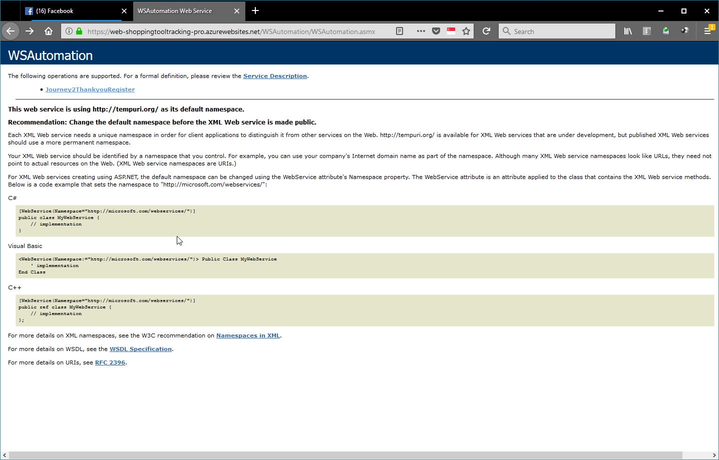

1. Test sent data via Postman
   1. Page Language EN
      1. Postman

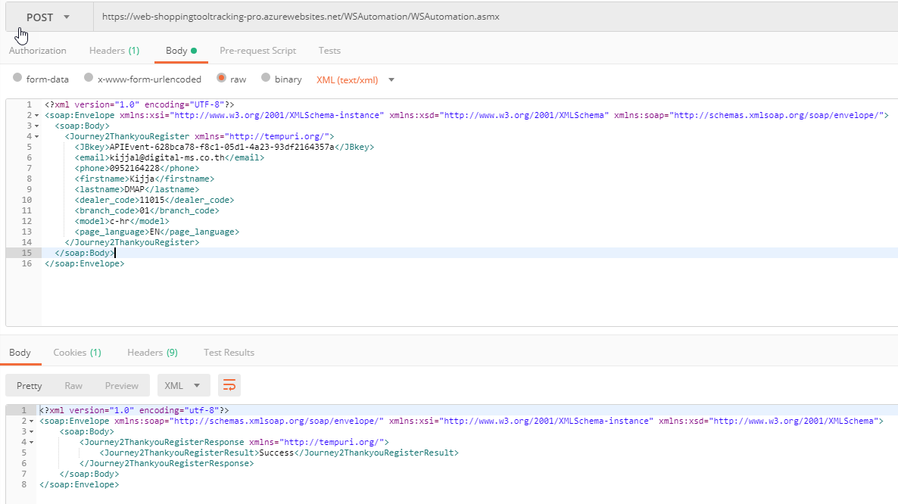

* + 1. Automation Log



* + 1. E-Mail

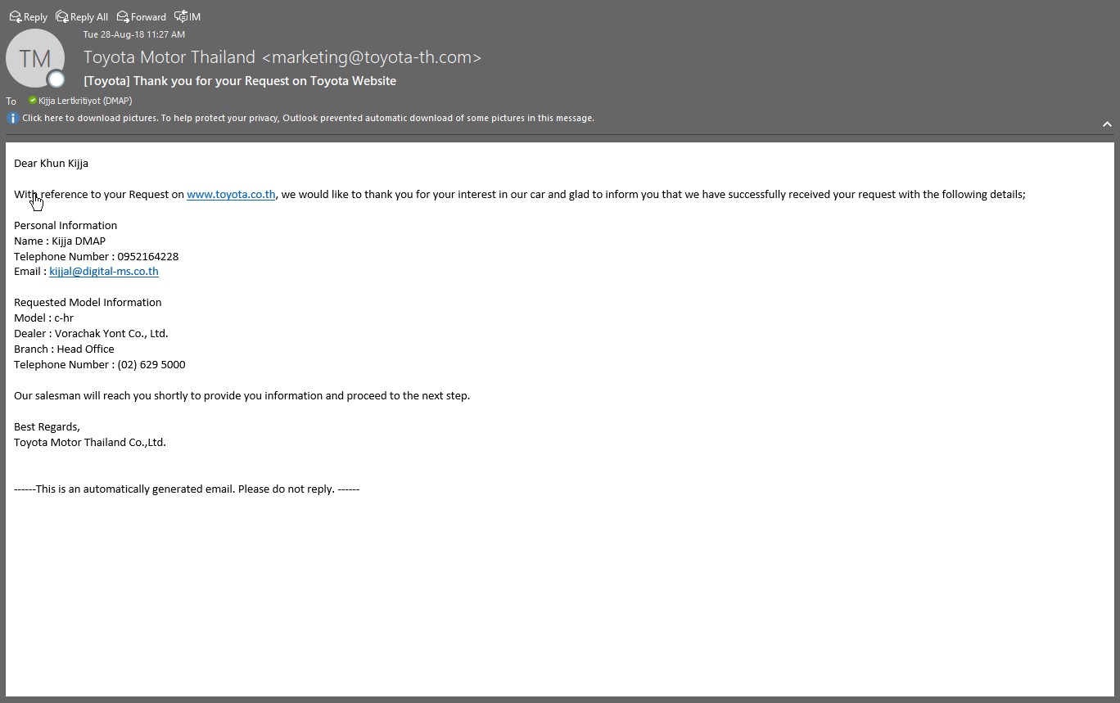

* 1. Page Language TH
     1. Postman

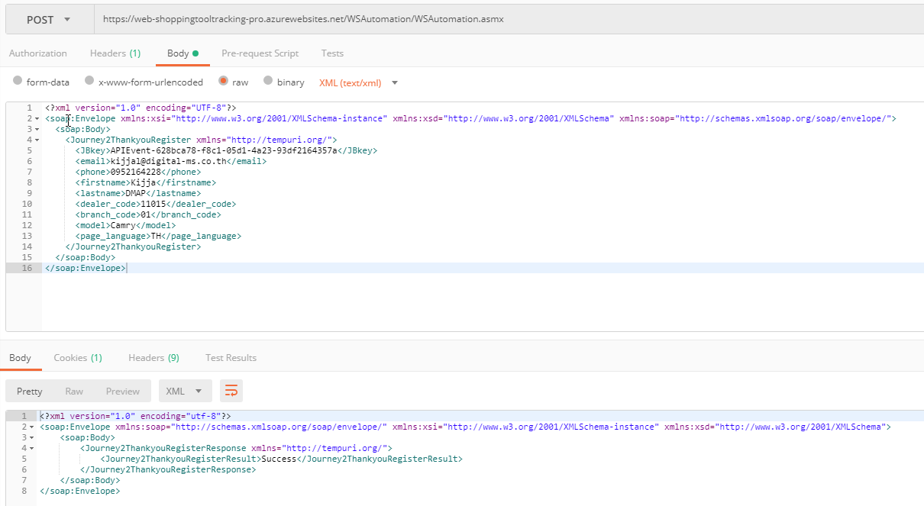

* + 1. Automation Log



* + 1. E-Mail

